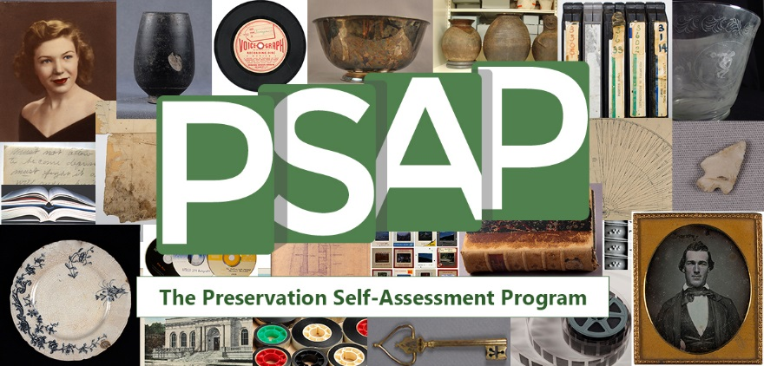

The Preservation Self-Assessment Program (PSAP) has expanded to include museum objects!
The University of Illinois and its project partners are proud to announce the expansion of the Preservation Self-Assessment Program (PSAP) to include ceramic, glass, stone, and metal object materials. The PSAP is a free online tool that helps collection managers at libraries, archives, and museums prioritize efforts to improve conditions of collection materials. In addition to functioning as a resource that advises on the many facets of collections care, the PSAP offers guided evaluation of items and collections, storage/exhibit environments, and institutional policies. By producing reports on the factors that impact the health of cultural heritage materials and defining the points from which to begin care, the PSAP helps collection managers and curators decide upon potential actions they may take to extend the life of their collections.
The PSAP is meant to be utilized by libraries, archives, museums, historical societies, and any other organizations that collect paper documents/books, photographic and image materials, audiovisual media, and objects. Like the Audiovisual Self-Assessment Program (AvSAP) which preceded it, the PSAP is designed to assist in organizations where little to no prior preservation training exists. In addition to the assessment functions, the PSAP also offers the Collection ID Guide, a stand-alone guide that can assist collection managers in identifying the materials and formats in their collections and provide useful advice on that material type's history, composition, preservation challenges, and optimal storage and display.
Our goal is to help collections managers develop prioritized preservation plans as well as to educate them on the “health risks” posed to their collections and what they can do to mitigate them with the resources at hand. This foray into museum objects broadens the tool’s assessment capabilities and makes the PSAP useful to a wider range of institutions! The expansion of the PSAP into museum objects was made possible by a no-cost-extension of a National Leadership Grant by the Institute of Museum and Library Sciences (IMLS), and leadership from the University of Illinois Library in partnership with The Spurlock Museum, the Illinois State Archaeological Survey (ISAS), the Illinois Heritage Association, and others.
For more information on the Preservation Self-Assessment Program visit the PSAP website at
https://psap.library.illinois.edu/

