Photograph Scanning Project
Begun February 2017
Equipment
Epson Perfection V370: scanner
Seagate: external hard drive
Past Perfect: museum catalog software

Scanning Procedure
1. Select next photograph/negative/slide from the archival storage box.
2. Find its number and make a note of it; its number will become the image file number (Review museum numbering standards in Cataloging Procedures Binder to help you identify it).
3. Place photograph on scanning bed so that the image is upright facing the glass in the corner marked with an arrow (see alternate procedure if image is a negative or slide)
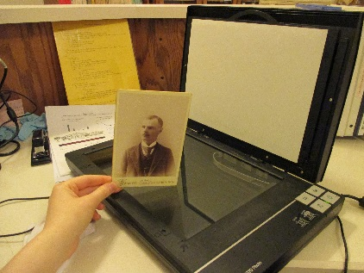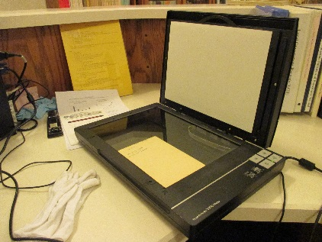
4. Open scanning software using the “Epson” shortcut on the computer desktop
5. If not already selected, use the dropdown menu in the upper right corner to select “Professional Mode”
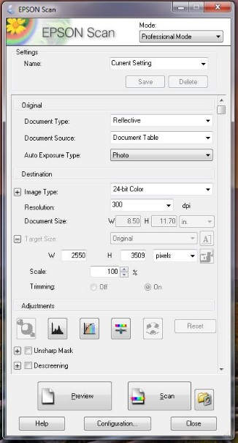
6. Set the file type and save settings. Select the button in the lower right that has a folder icon 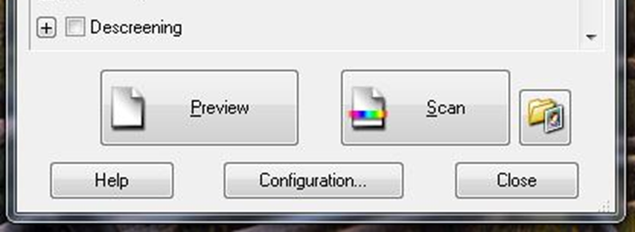
Settings should be as follows:
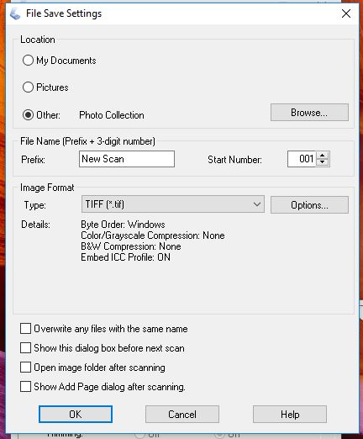
- Set “Location” to “Other” and Browse.
- Select file “Photo Collection” (lives on the desktop).

- Set the file name to “New Scan” (or any other identifier that will help you find the file later).
- Set the Image Format Type to “TIFF” using the dropdown menu.

- Uncheck any of the boxes near the bottom

- Select “OK” to close

Save settings will remain the same until changed so this only needs to be done once before the first scan.

7. Make sure the photograph is straight and the scanner lid is closed and select the “Preview” button near the lower left corner.
8. Once the Preview window is open, use your mouse to select the field in the preview screen around the image, keeping as close to the image as possible without losing any of it.
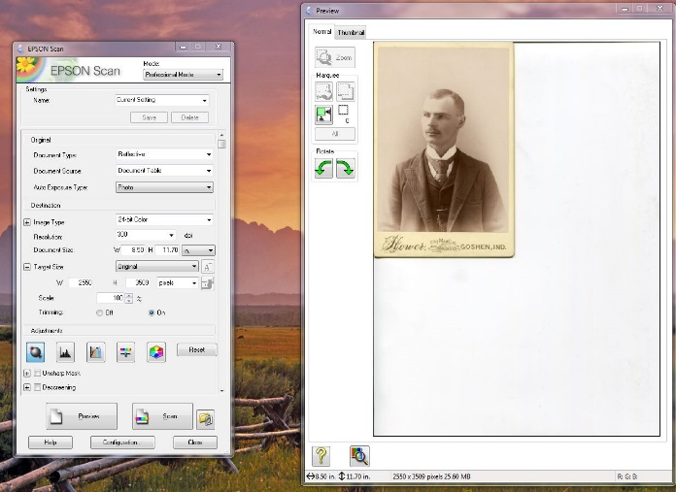
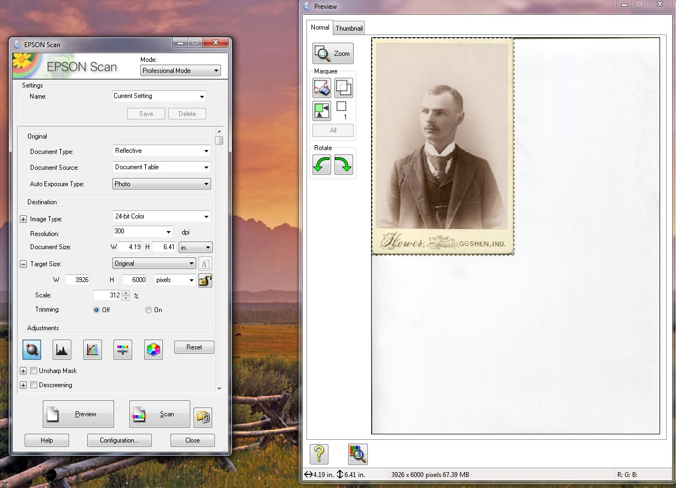
9. Select your scan settings. For a photograph, scan setting should match these:
- These dropdown menus are hierarchical so you will need to start by setting the “Document Type” first and work your way down the first four; “Resolution” and “Document Size” do not need to be set or adjusted, they can be ignored

- Set the Target Size dimensions to “pixels” and set the largest dimension to 6000 (in this case, the picture has a greater height than width so the largest dimension is height, “H”)
- Set “Trimming” to “Off”

- Make sure all boxes in the “Adjustments” field are unchecked
10. Scan by selecting the “Scan” button
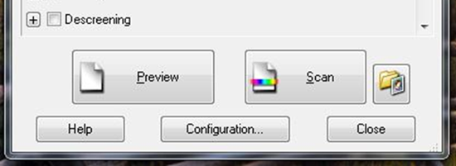

If you get the following alert, select “Continue”
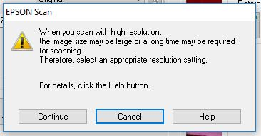

11. Once the scan is finished (it may take a couple minutes), open the “Photo Collection” folder on the desktop and find the new scan. Renumber the image file with the image’s number.

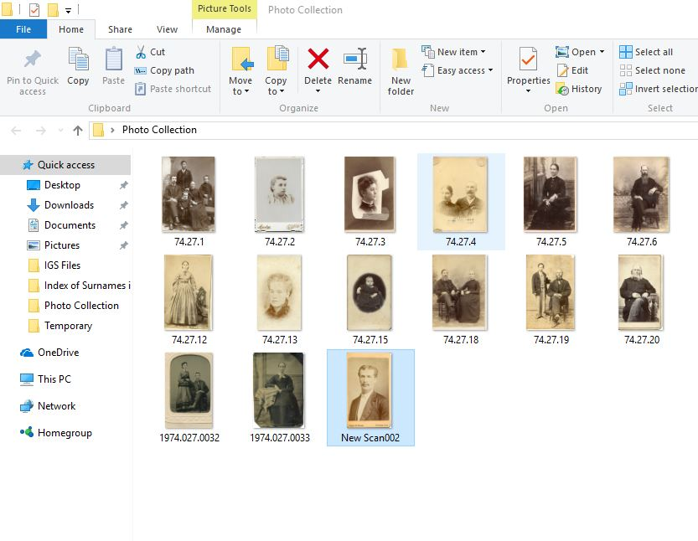
Past Perfect/Seagate Procedure

1. Open Past Perfect and select the “Photos” catalog
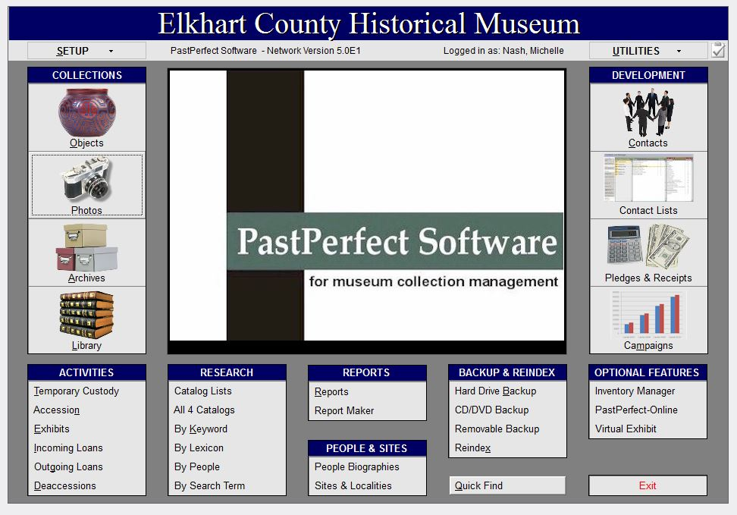
2. Open the Seagate “Temporary” file and select an image by identifying its file name (which is its Object ID)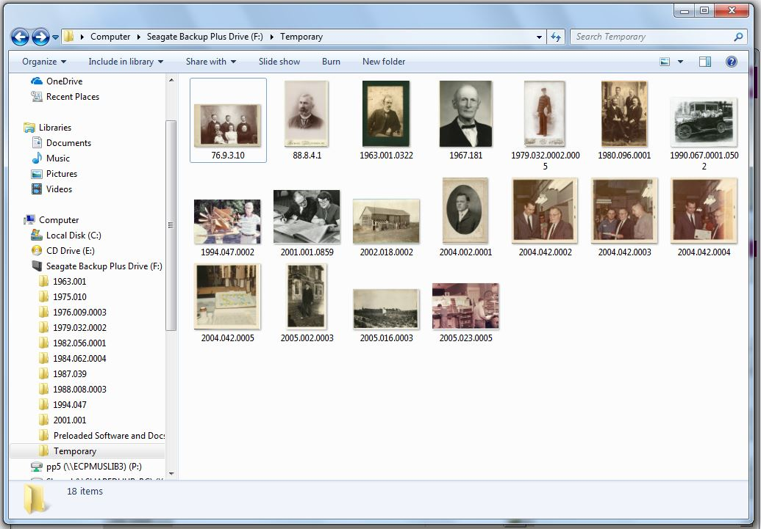

3. Use the “Find” button in Past Perfect to locate the record for the image. You may need to add leading 0s, the full year or search under “Other #” or “Old #”to find the record (Review museum numbering standards in Cataloging Procedures Binder to help you find it).
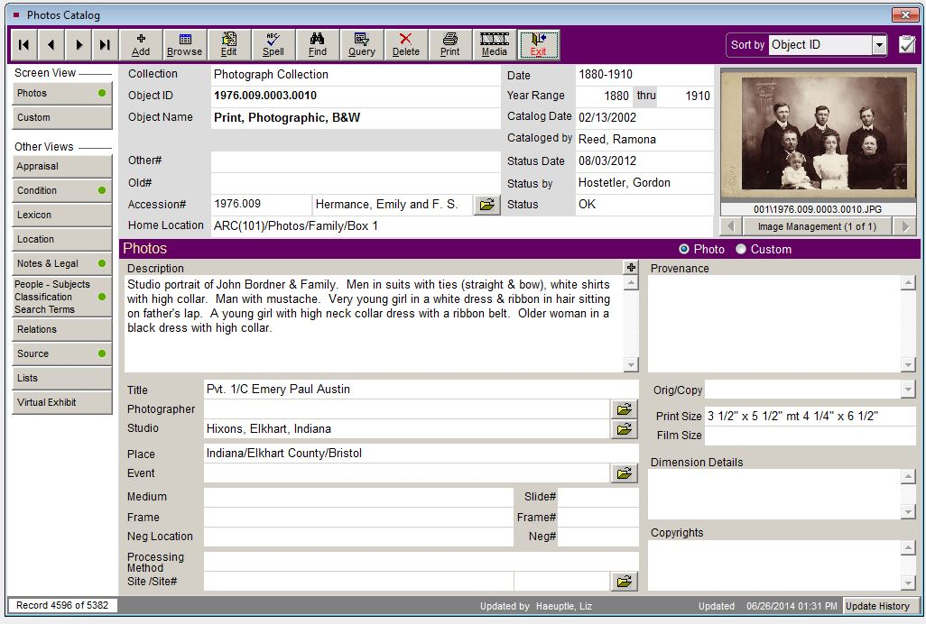
***If the image file name does not match the Past Perfect “Object ID” exactly, rename the file so that it does***
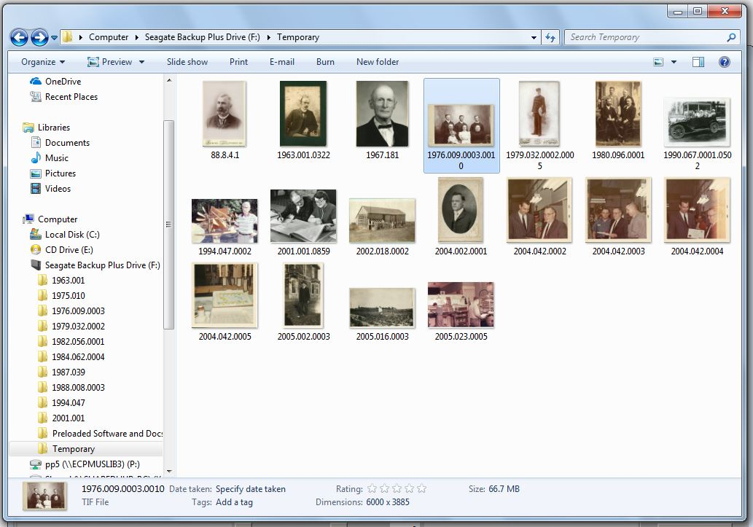

4. To begin attaching the file, select the “Image Management” Button near the upper right for the catalog screen
5. If there is already an image attached that is not watermarked (as pictured), remove it by clicking on the garbage can icon under “Remove Image” and select “Yes” at the prompt.
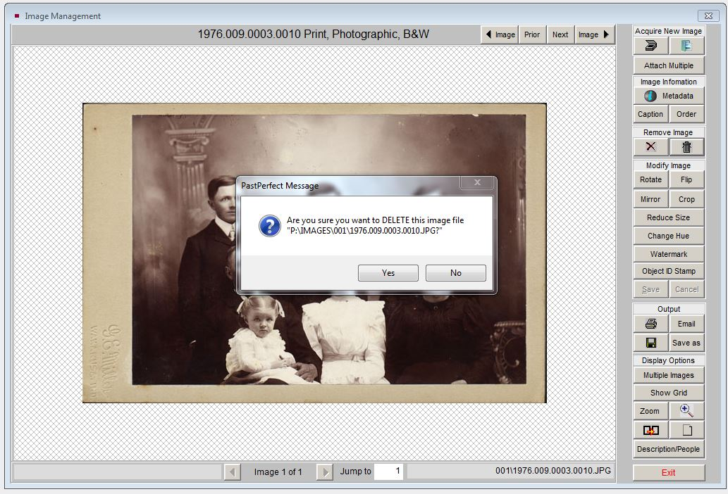

6. Select the folder icon under “Acquire New Image” in the top right corner
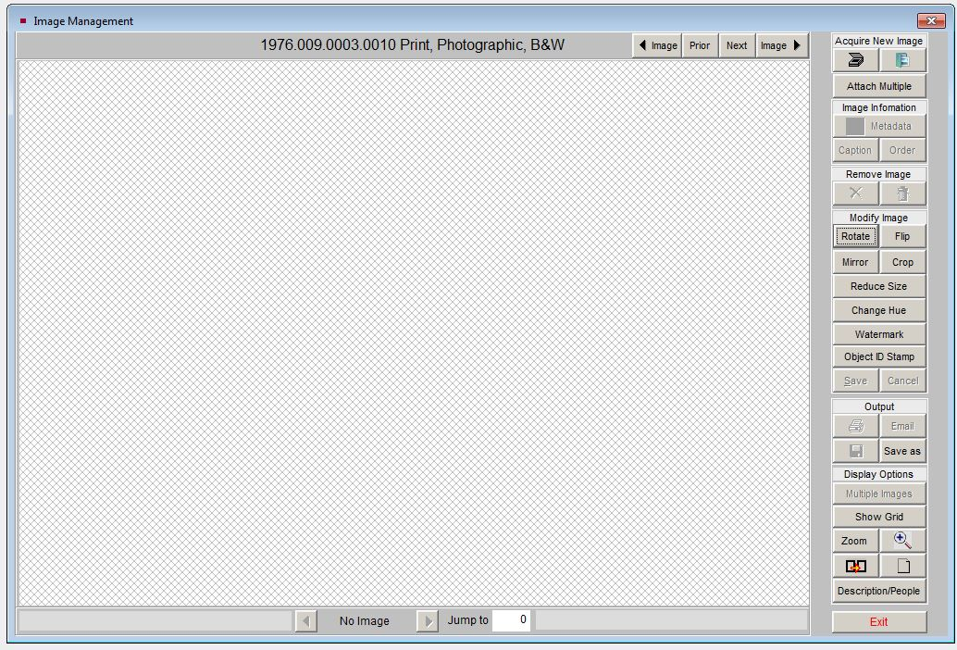

7. Find the image file in the Seagate “Temporary” folder and double click or select “Open”
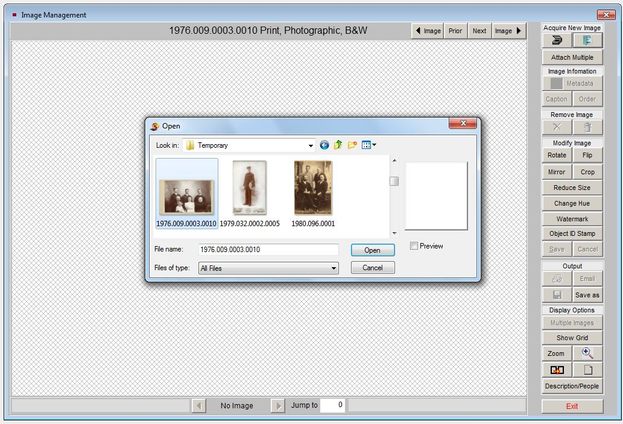
8. When the Metadata window opens, update the following information:
- Identify the format of the original (photograph, slide, negative) and select it from the dropdown menu. If unsure, ask a staff person
- Select scanner and software from the dropdown menus of “Equipment Used to Acquire” and “Software Used to Acquire” to match what is shown here (no entry for “Settings and Resolution”)
- Enter your name if you scanned the image under “Created By” otherwise ask a staff person who the scanner was (shortcut is to hit F7 and select it from the list)
- Enter date the image was scanned (will be identified in image properties in Seagate file)
- Enter “Seagate hard drive” as the “Location of High Resolution Archival Image”
- To close, select “Save” and “OK”
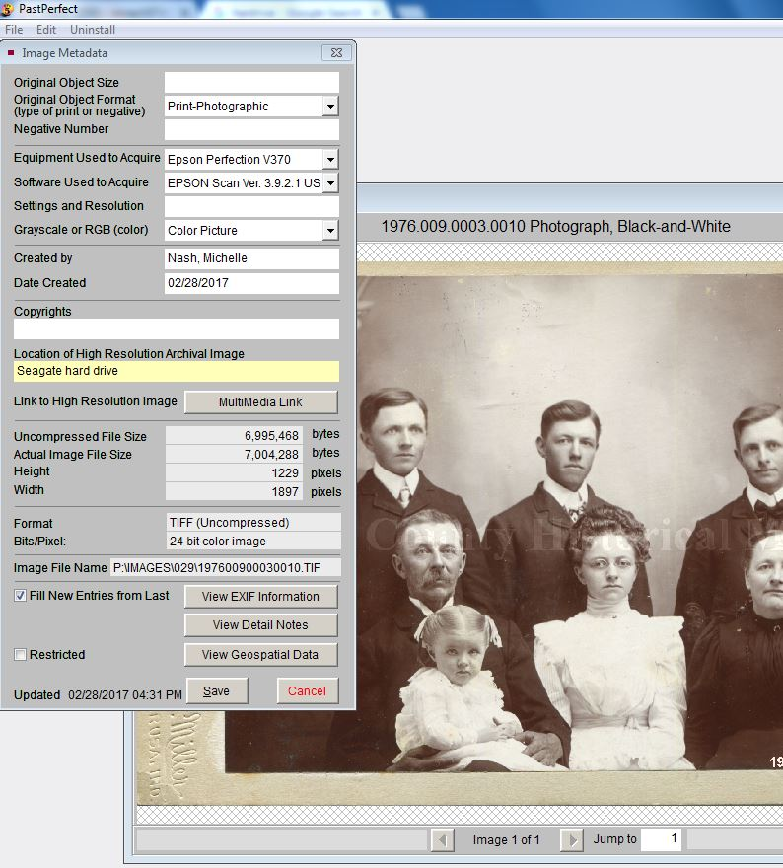

9. Select “Reduce Size” in the right-hand menu and adjust the size to 10%, then select “Save”
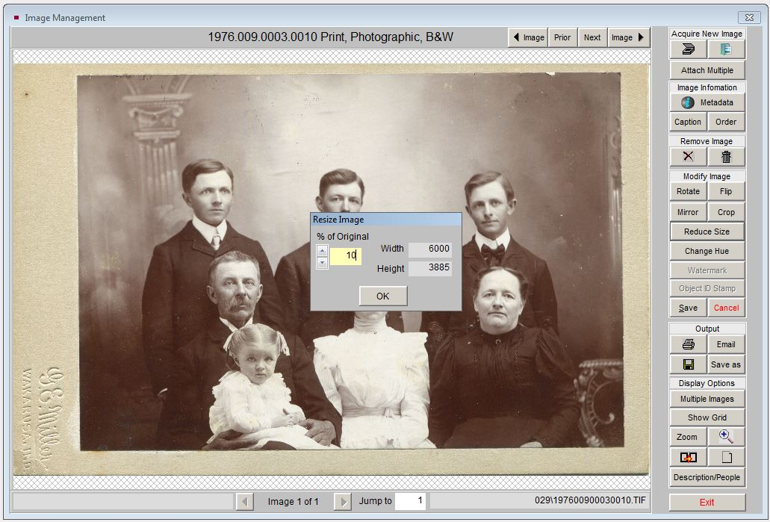
10. Select “Watermark”, confirm the watermark location is set to “Middle” and then select “Apply Watermark” and “Exit”. Save again.
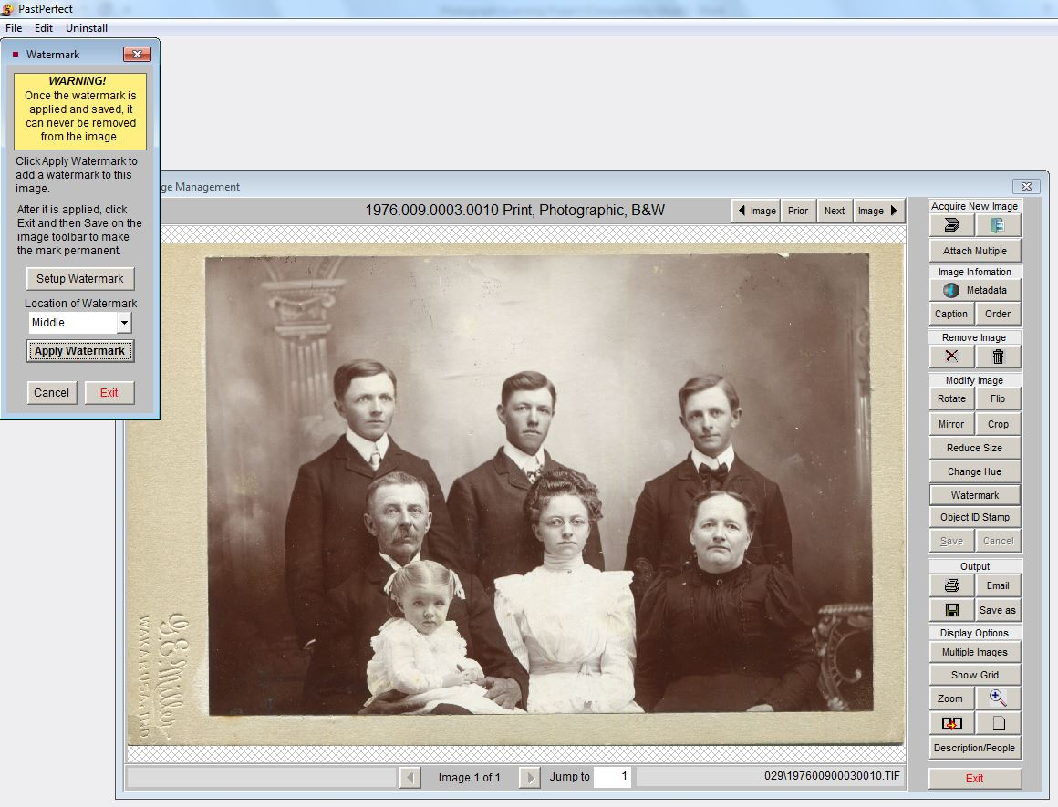
11. Select “Object ID Stamp”, confirm the stamp is set to “Small” and “Right”. Choose white or black depending on the photo background (If either is acceptable, default to white). Select “Apply Stamp” and “Exit”. Save a final time and Exit the Image Manager
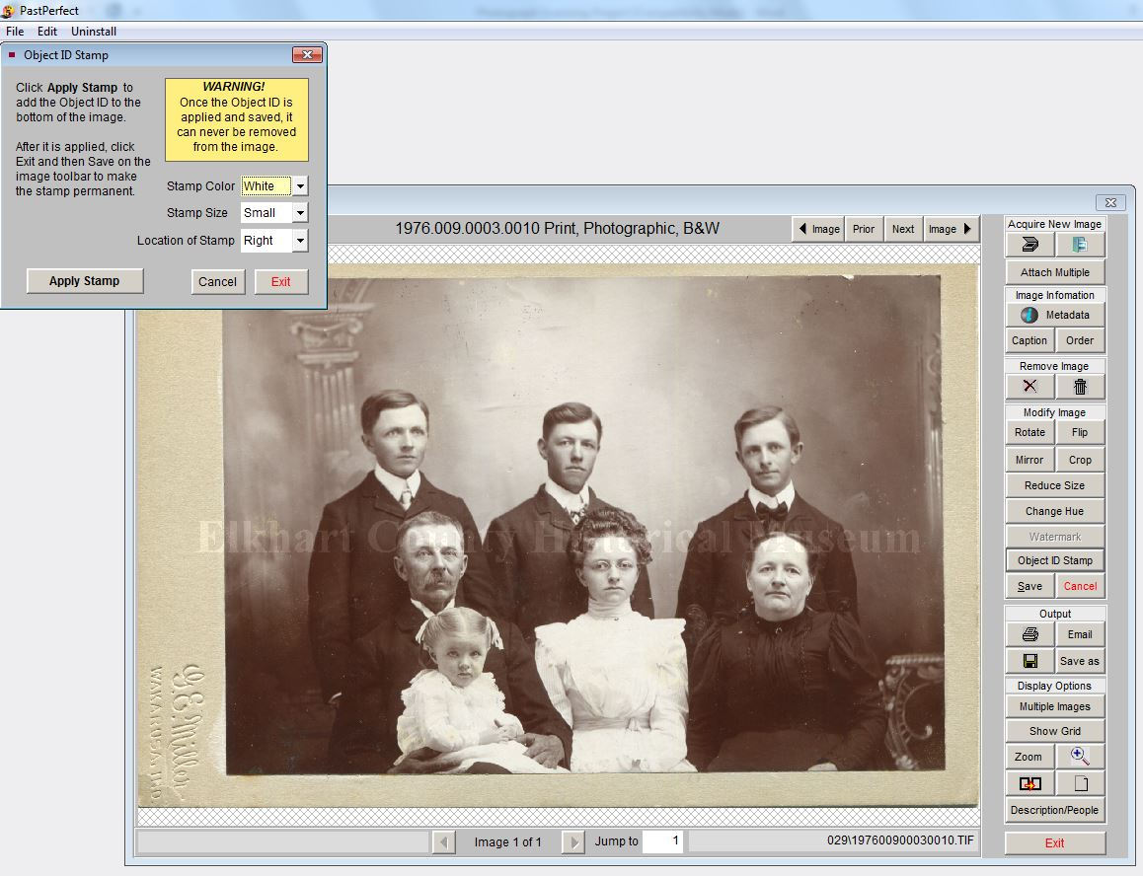

12. Record updating of record by selecting “Edit” in the main catalog record and changing “Status Date” to today’s date, “Status by” to your name and “Status” to “Record Updated”
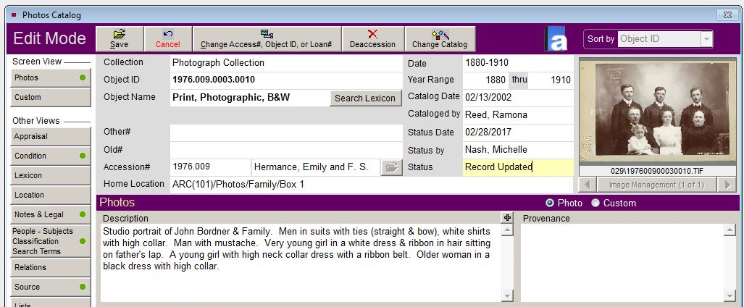
13. Select Save to save changes to the catalog record. If you receive the following prompts:
- Field Verification Alert: select “Save As Is”
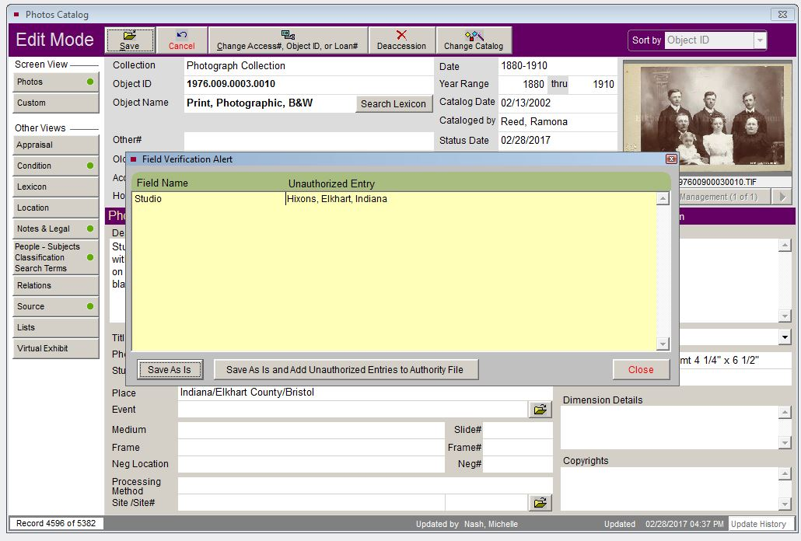
- “This Object Name is Not in the Lexicon”: Choose “Select a Different Object Name form the Lexicon” and select “Photograph” (or “Photograph, Black-and-White” “Photograph, Cabinet” or “Photograph, Color” depending on the original) from the list provided.
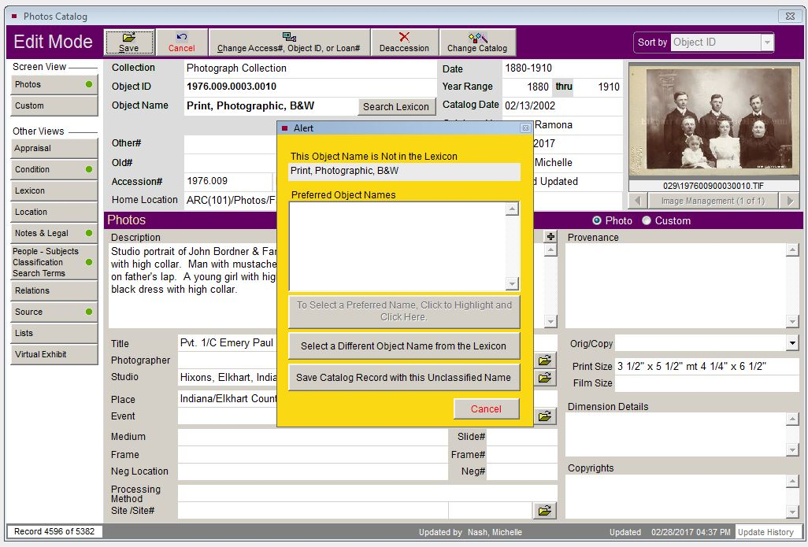
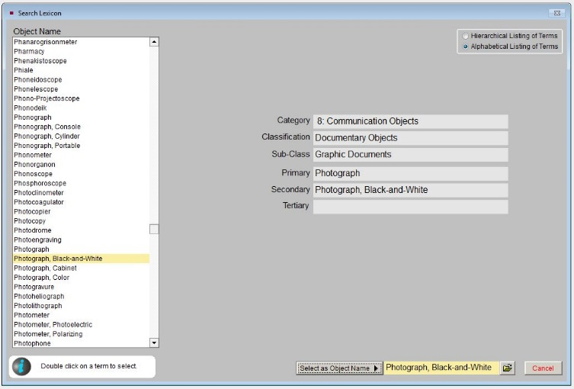
14. Move the original image file on the Seagate hard drive to the folder “Attached to PP”

